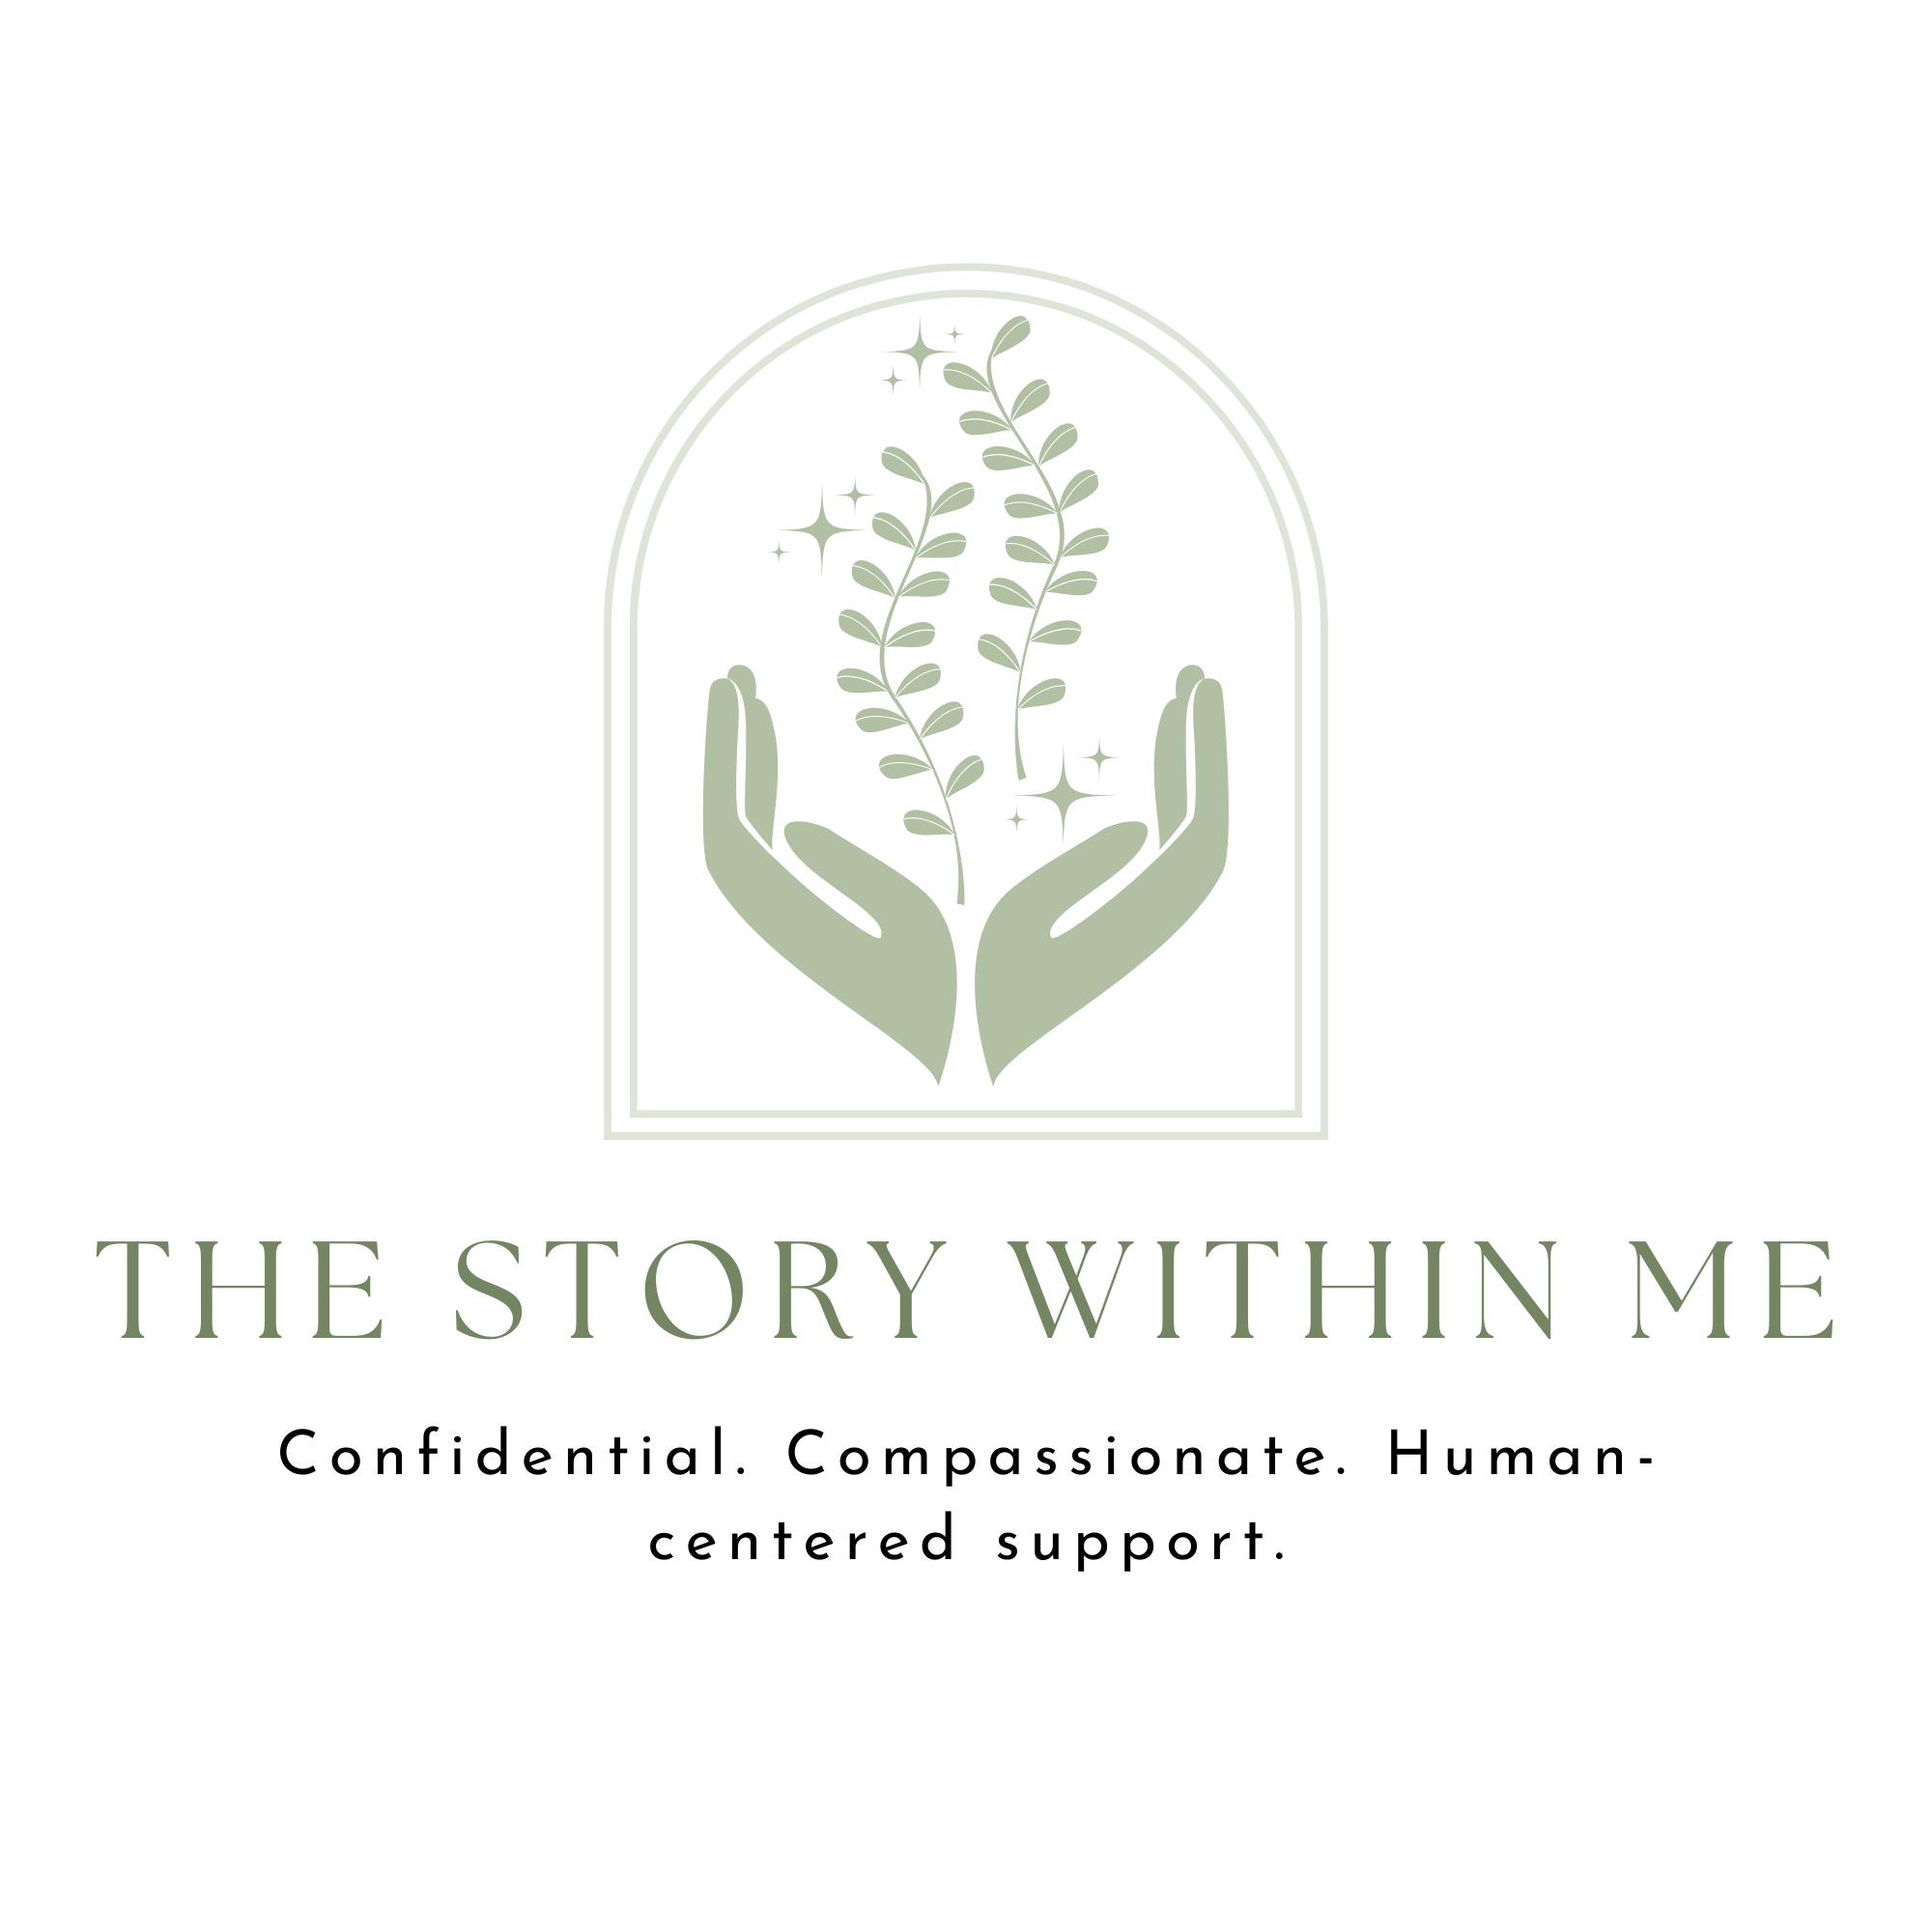

We are dedicated to empowering individuals to improve their overall wellbeing, achieve their personal goals, and build a more secure future. Through our wellness program, personal development services, and support solutions, we provide practical guidance and resources designed to help people live healthier, happier, and more balanced lives.

Our commitment is to deliver professional, confidential, and personalized services with integrity, compassion, and excellence, ensuring that every individual receives the support they need to grow and succeed.

PROGRAM REGISTRATION PACK
Participant Registration • POPIA Consent • Program Agreement

Section A: Personal Details
Full Name: __________________________
ID/Passport: ________________________
Date of Birth: ______________________
Gender: _____________________________
Nationality: ________________________
Address:
________________________________
________________________________
Email: _____________________________
Mobile: ____________________________

Section B: Emergency Contact

Name: ______________________________
Relationship: ______________________
Phone: _____________________________

Section C: Program Information

Program: ___TheStoryWithinMe_________________________
Inclusions: ___Complete Benefits_________________________

Section D: Banking Details
Account Holder: _____________________
Bank: ______________________________
Branch Code: _______________________
Account Number: ____________________
Account Type: ______________________

Section E: Medical & Accessibility

Medical Conditions: __________________
Accessibility Needs: ________________

Section F: Supporting Documents
☐ Certified ID ☐ Proof of Residence ☐ Bank Confirmation

Participant Agreements
Code of Conduct: I agree to behave respectfully, follow organisational policies, attend scheduled activities, and protect confidential information.
Communication Consent: ☐ Phone ☐ SMS ☐ WhatsApp ☐ Email
Photography Consent: ☐ Yes ☐ No

POPIA Consent
I consent to the collection, storage and processing of my personal information for administering this programme, communicating with me, processing payments where applicable, reporting to funders where legally permitted, issuing certificates, and complying with applicable laws. I understand my rights to access, correct, or request deletion of my personal information where applicable.

Participant Declaration
I declare that the information provided is true and complete. I agree to the programme rules. I agree that a 30-day written notice needs to be provided for cancellation. I agree to the terms and conditions of this program.
Participant Name: __________________________
Signature: ____________________ Date: ____________________
Parent/Guardian Consent (Under 18)
Parent/Guardian: ____________________
Relationship: ____________________
Signature: ____________________

Once-off fee of amount R200 (Two-Hundred only) to be paid upon signing the above document payable via EFT or direct transfer using a swift code. A proof of payment needs to be provided via email to info@thestorywithinme.co.za

Office Use Only
Reference No.: ____________________
Status: Approved / Pending / Declined
Received By: ____________________
Comments:
________________________________

